**NETWORK ANALYSIS ON FOOD RECIPES**

In our previous project we did the analysis on 16 recipes but now we have done the analysis on 55 Pakistani recipes.

Graph 1 represents the ingredients

Graph 2 represents the recipes

**Data source:**

<http://www.khanapakana.com/recipes.aspx>

We collected recipe from this website from the following categories

* Breakfast
* Burgers
* Fast food
* Kebabs, Tikka, cutlets
* Mutton
* Rice
* Sandwich
* Seafood

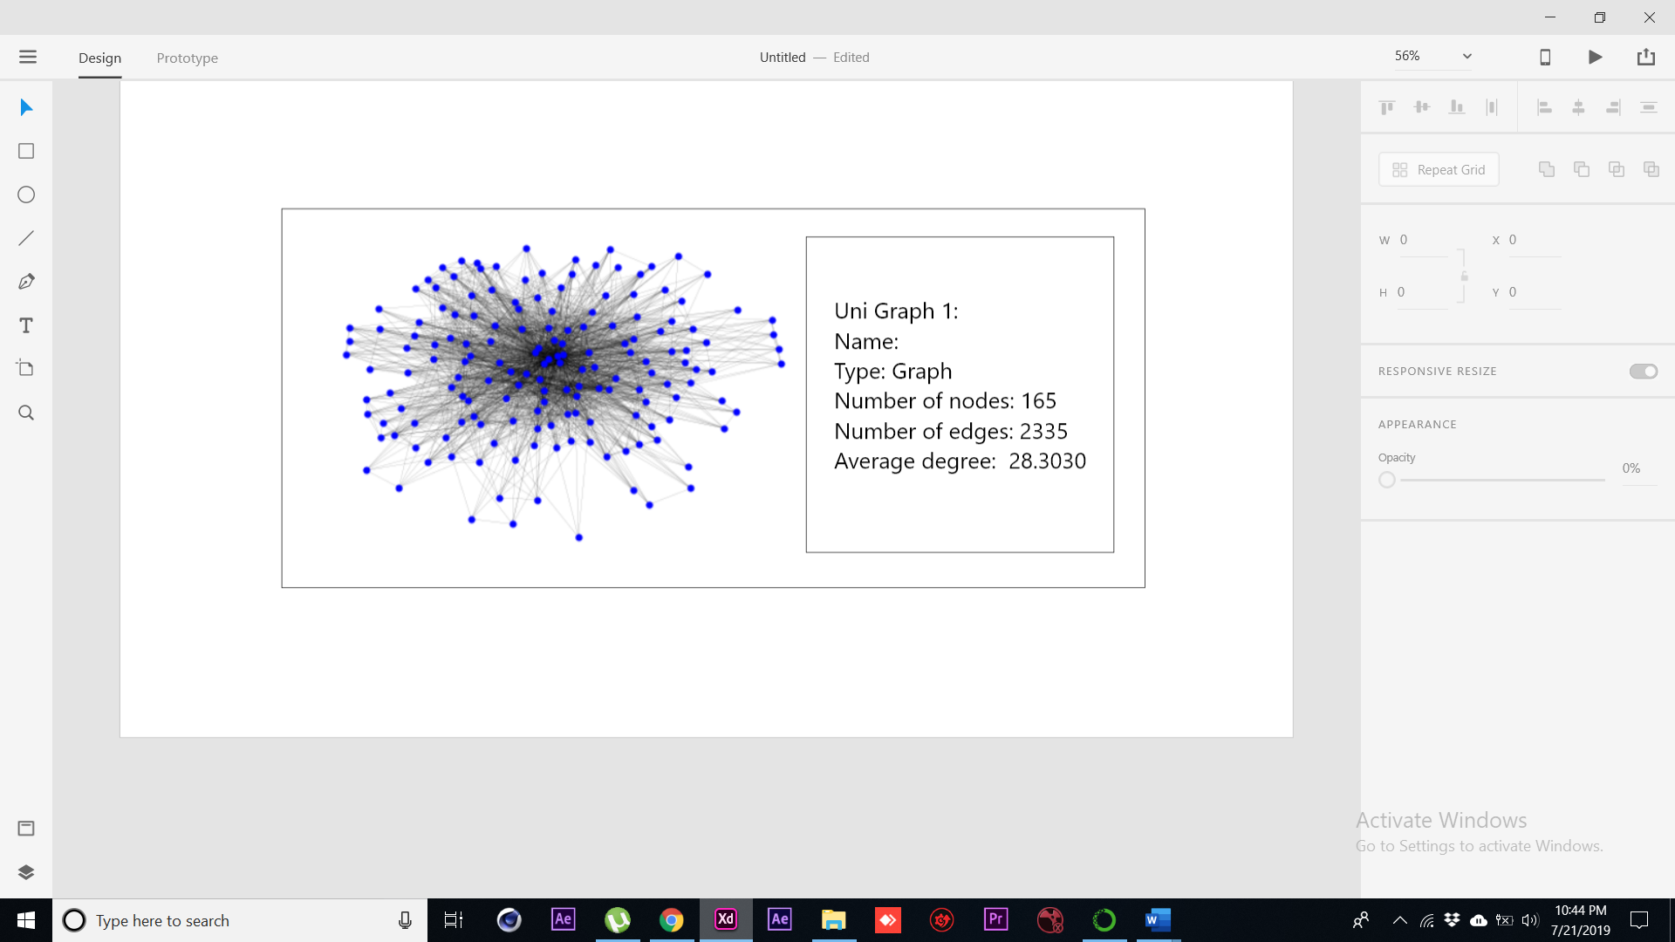

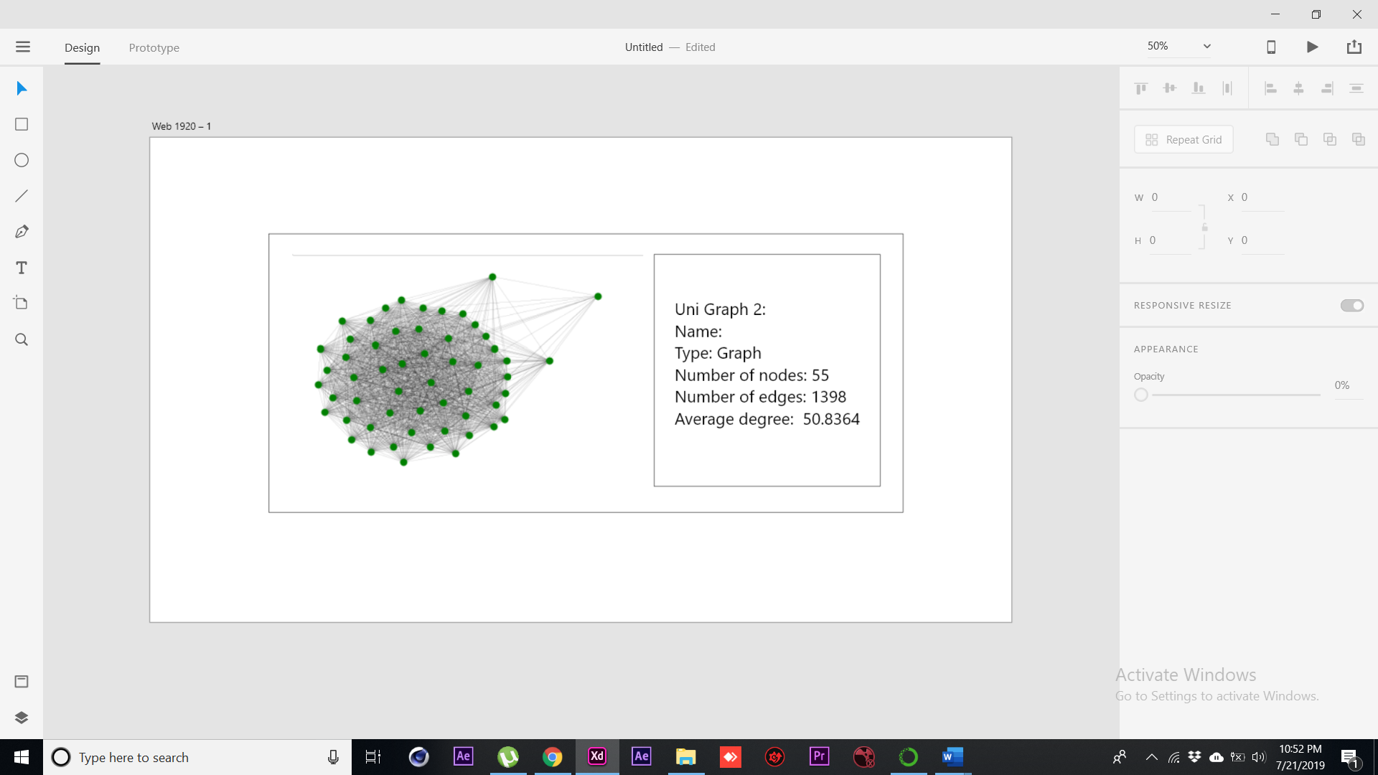

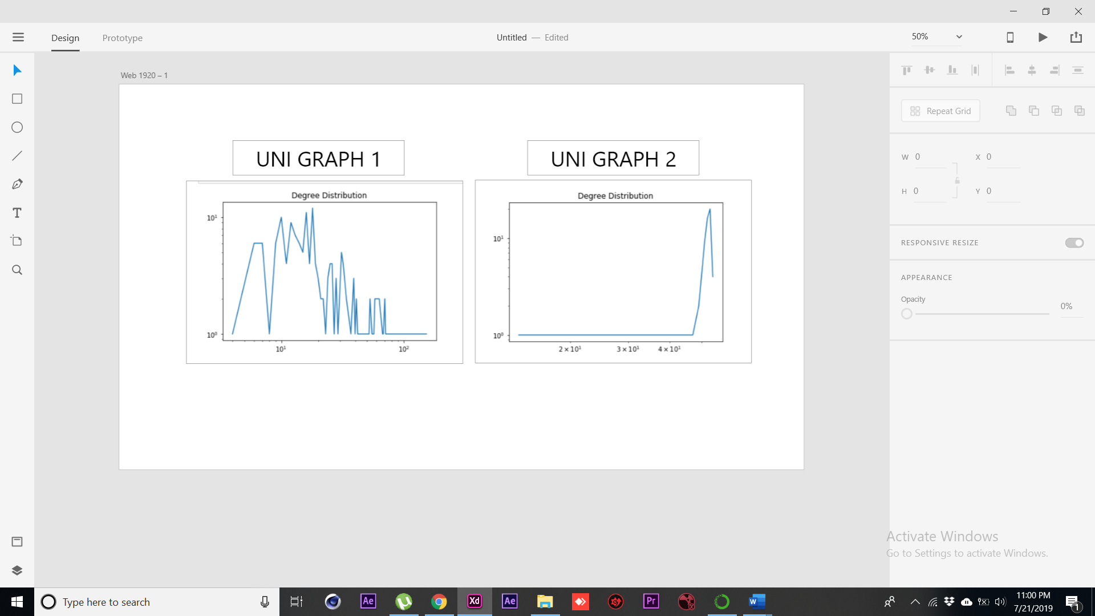

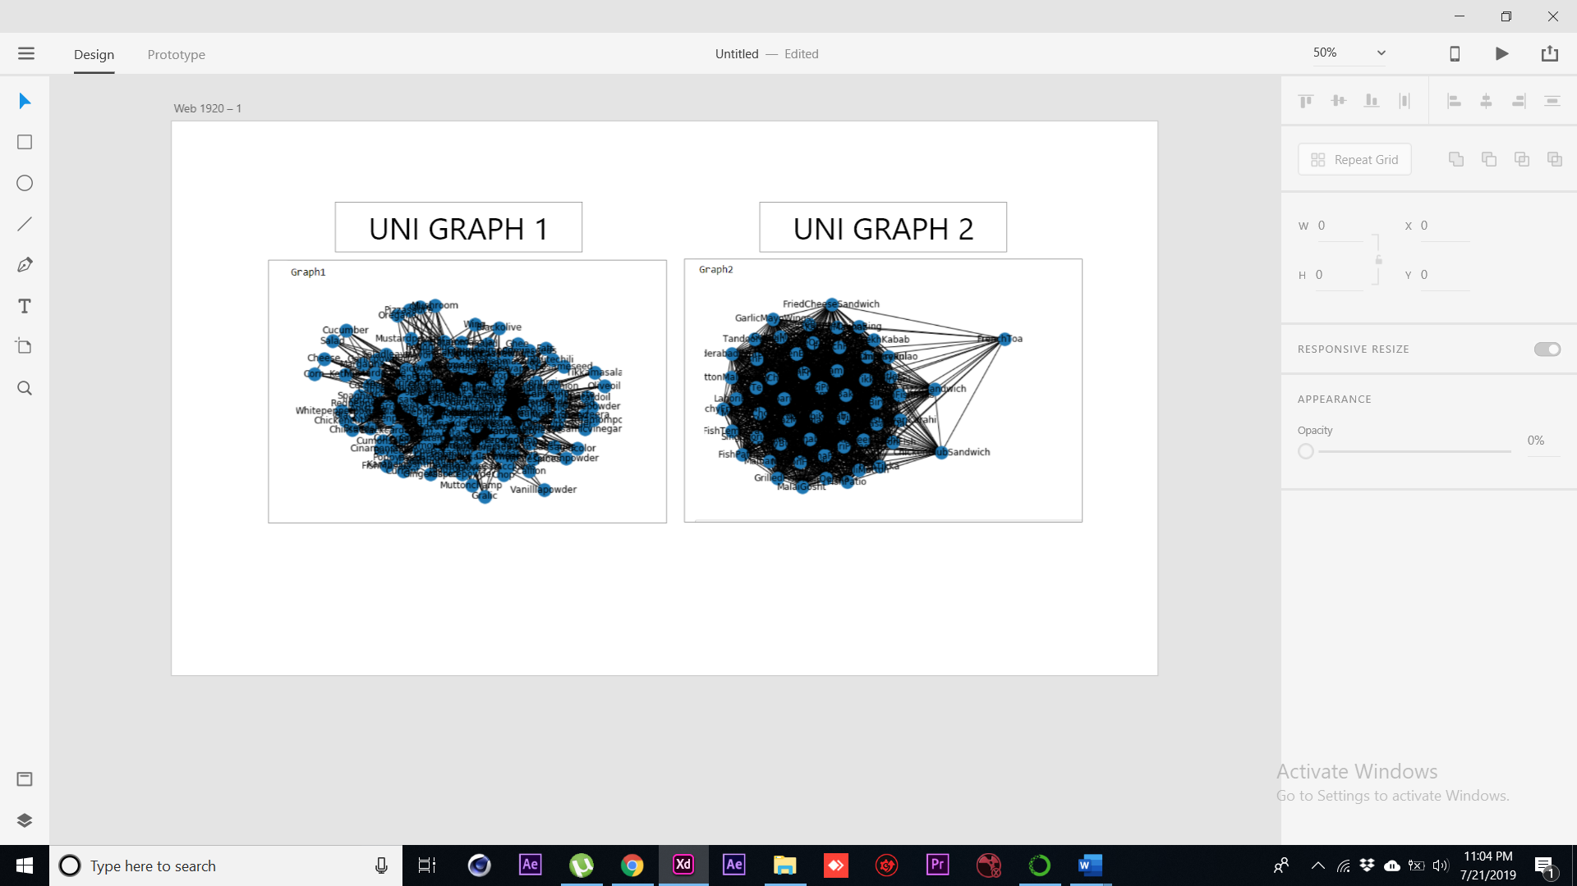

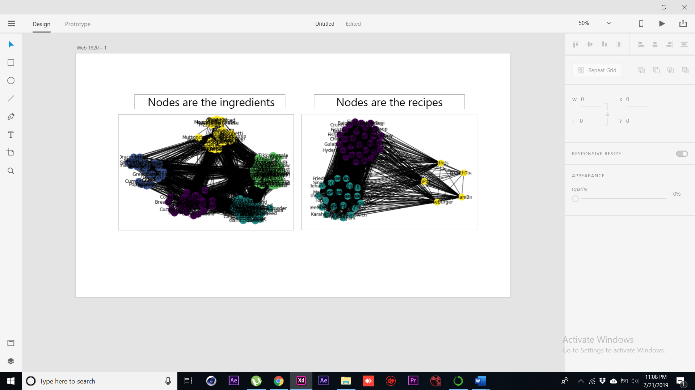

**Group Members:**

Haris Lania 18B-089-CS

Usaid Khan 18B-079-CS

Bilal Ul Haq 18B-120-CS

Rohaib Khan 18B-118-CS